Smart View Installation Guide
C-BIG

Office of Academic Planning & Budget
Updated August 2021

Contents

1. Smart View Overview 3
2. Installing Smart View 3
2a. Setting Up Smart View Connection 4
2b. Connecting to Smart View 8
2c. Setting Smart View User Options 9

Smart View Installation Guide
This training guide has been created to enable users to install the Excel Smart View add-in onto their computers. This will allow users to input their budget into C-BIG through the Smart View and pull reports. If any questions come up during your review of the information, please feel free to contact APB at apbcbig@ponet.ucla.edu, or contact someone from the APB Financial Analysis & Decision Support Team.

Smart View Overview
- Microsoft Office add-in for Oracle Hyperion Planning applications
- Allows users to input data through templates created for C-BIG
- Provides ad-hoc query capability to users in a familiar Excel environment
- Allows users to dynamically access the live data and develop their own queries
- Allows users to pull CBIG reports to manipulate in Excel

Installing Smart View
The following steps can be used to either update your version of Smart View, or installing it for the first time. Your IT team might need to help since you need Administrator rights to download the latest version.
Updating Smart View
If you have an old version of Smart View already, it must be uninstalled before the new one can be installed.
Here are the steps to uninstall.
- Navigate to Control Panel then Programs and Features.
- Find Oracle Smart View for Office and double click.
- Click Yes on the confirmation dialog. Note: You will need to close all Office applications so save any work.
- Once the uninstall completes, you must reboot your computer.

Downloading & Installing Smart View
- To download, go to the APB C-BIG webpage and in the C-BIG Resource Section select the #2 hyperlink for the “Latest Smart View Version”. The link will direct you to a folder in Box which includes an .exe file.
- Download and install - be sure to right-click the .exe file and select Run as Administrator when installing.
- Open Excel and verify that the Smart View tab is there.

If there are other Excel Add-ins installed, you may need to disable them for Smart View to run properly (i.e. Acrobat PDFMaker Office COM Addin). Go to File > Options > Add-Ins > Excel Add-ins > Go… and uncheck add-ins you would like to disable (see image below).

If Smart View is installed, but does not appear in Excel, make sure Oracle Smart View for Office is checked under both Excel Add-ins and COM Add-ins.
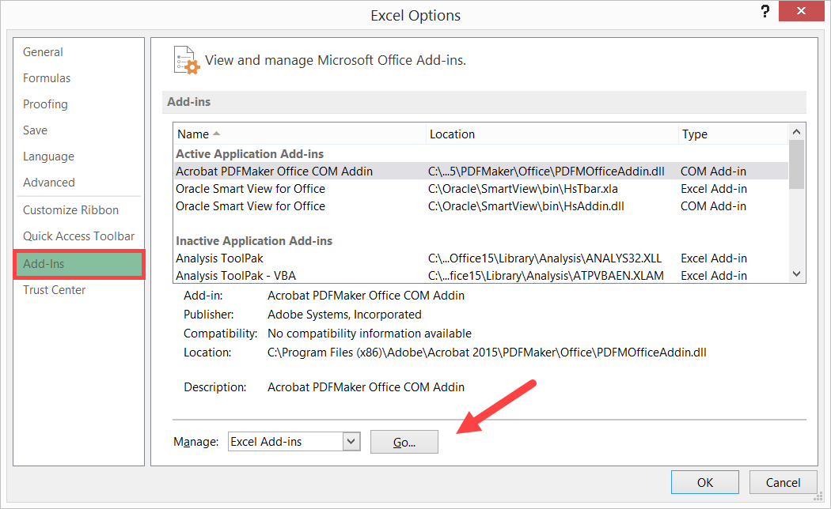

2a. Setting Up Smart View Connection

- After the installation of Smart View is complete, launch Microsoft Excel.
- Select Smart View from the menu.
- In the Smart View Ribbon, select Options:
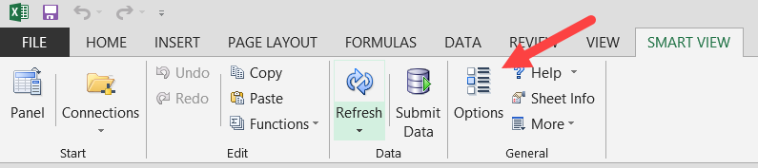
- Within the Options window, select Advanced.
- In the Shared Connections URL section (see example table on next page), copy the entire URL below and paste into the box:

https://planning-ehjw.pbcs.us2.oraclecloud.com/workspace/SmartViewProviders
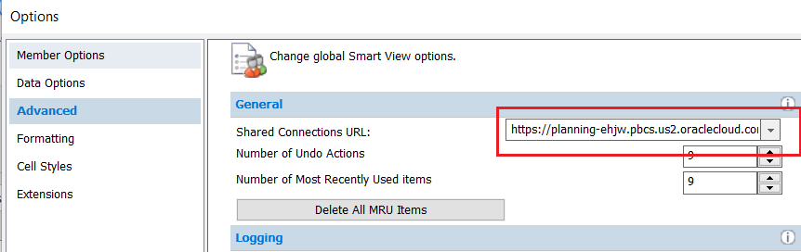
- Click OK.

If you receive the following message when trying to save your Options, please create a log file by following the steps below:
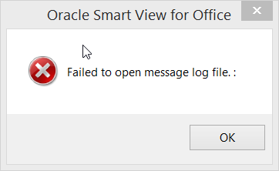

- In Options > Advanced, check Route Messages to File option and click on the elipses icon to search for a file location:
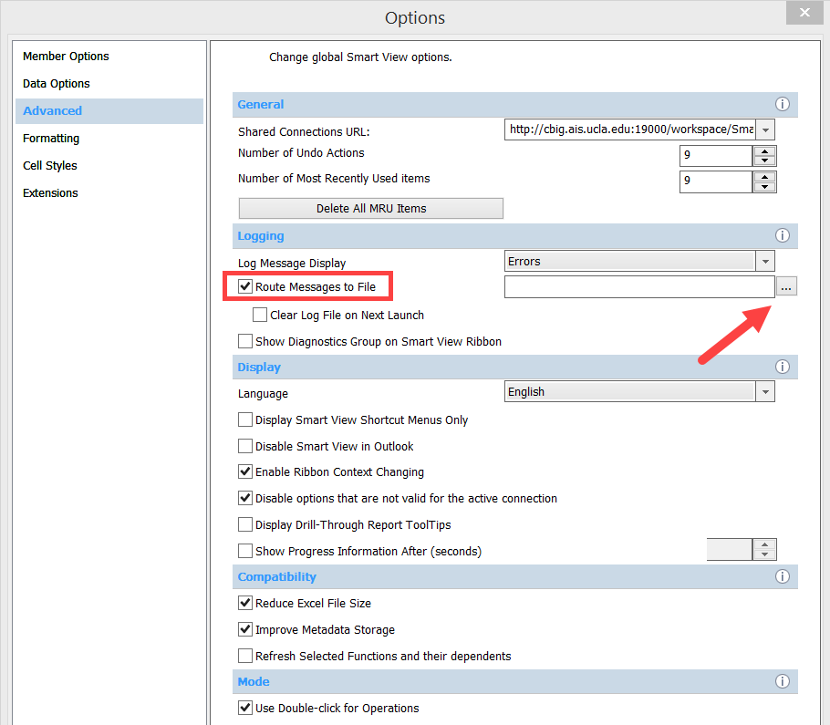
- At a folder/location of your choice, right-click and select New > Text Document.

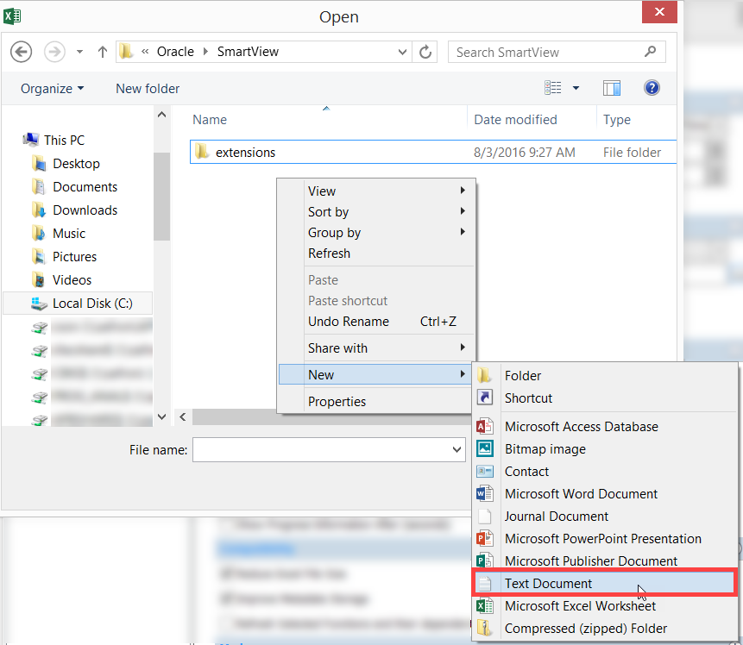
- Name your document “SmartViewLog.log” and select Open.
- Uncheck the Route Messages to File option and click OK > Save as Default Options:

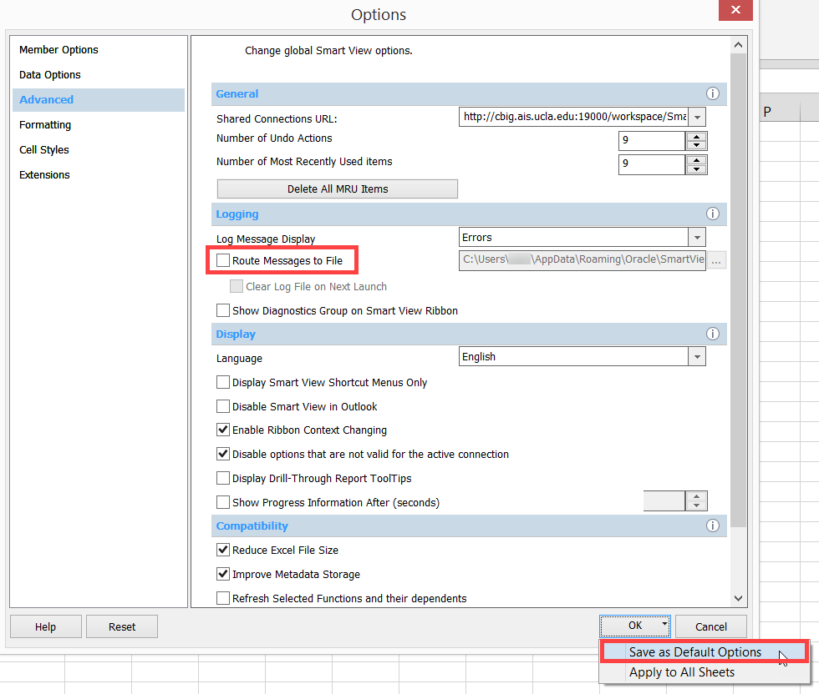

2b. Connecting to Smart View
- Click on the Smart View Ribbon.
- Click on Panel.
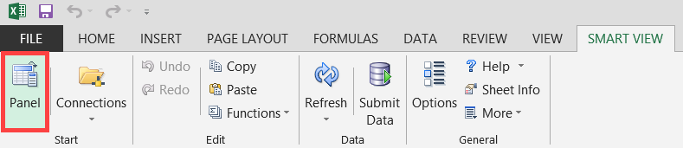
- In the Smart View panel, click on Shared Connections.
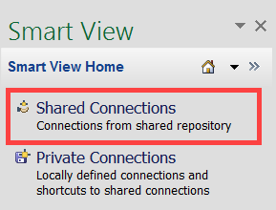
- Enter your User Name and Password and click Connect:
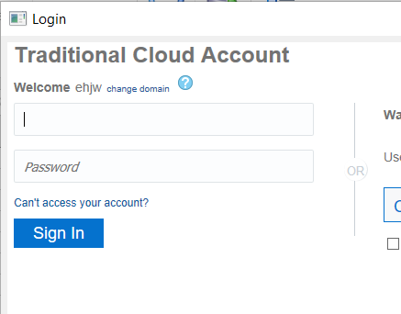
- Under Shared Connections, click on the dropdown that says "Select Server to proceed" and click Reporting Settings
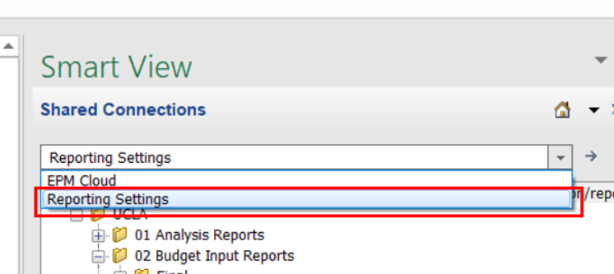

2c. Setting Smart View User Options
- From the Excel ribbon, click the Smart View tab.
- From the Smart View tab, click the Options icon:
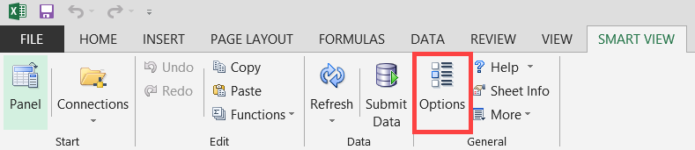
- Select Data Options and deselect all suppression options.
- Select #NumericZero from the dropdown for #NoData/Missing Label:
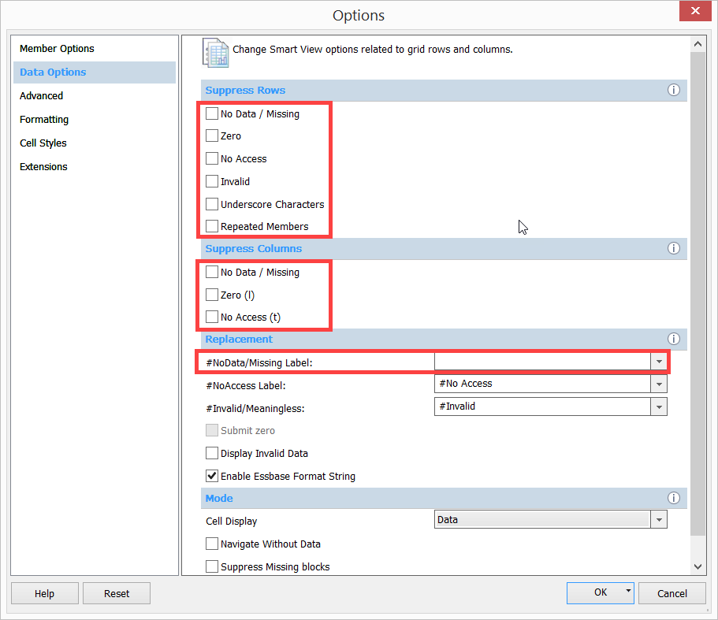
- In the Options, select Formatting and check the boxes for Adjust Column Width option and Use Thousands Separator. (This second check box makes the numbers display nicer in forms)
- Once the Smart View Options have been set, click the drop down arrow next to the OK button.
- Click Save as Default Options:
