Smart View Training Guide
C-BIG BUDGET INPUT

Office of Academic Planning & Budget
Updated August 2021

Contents

1. Smart View Overview 3
2. Installing Smart View 3
2a. Connecting to Smart View 3
2b. Setting Smart View User Options 4
3. Opening Input Forms through the Task List 5
4. Using Budget Input Forms 10
4a. Selecting Department & Fund 11
4b. Inputting and Submitting Budget Data 12
4c. Adding Cell Comments 12
4d. Adding Supporting Details 14
4e. Adjust 16
4f. Copying and Pasting 17
4g. Applying Excel Formulas 17
4h. Running Calculations 18
5. Data Validation 19
5a. Deficit Budget Check 19
5b. Spread Check 20
6. Approval Process 20
7. Logging Off Smart View 21
8. Troubleshooting 21

Smart View Training Guide
This training guide has been created to enable users to input their budget into C-BIG through the Smart View add-in. If any questions come up during your review of the information, please feel free to contact APB at apbcbig@ponet.ucla.edu or contact someone from the APB Financial Analysis & Decision Support Team.

Smart View Overview
- Microsoft Office add-in for Oracle Hyperion Planning applications
- Allows users to input data through templates created for C-BIG
- Provides ad-hoc query capability to users in a familiar Excel environment
- Allows users to dynamically access the live data and develop their own queries
- Allows users to pull CBIG reports to manipulate in Excel

Installing Smart View
To either install Smart View for the first time or update to the latest version, please go to the APB C-BIG webpage and in the C-BIG Resource Section at the bottom select the #1 hyperlink for “installing and Updating Smart View” and also #2 hyperlink for the “Latest Smart View Version”.

2a. Connecting to Smart View
- Click on the Smart View Ribbon.
- Click on Panel.
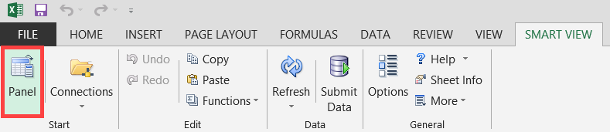
- In the Smart View panel, click on Shared Connections.
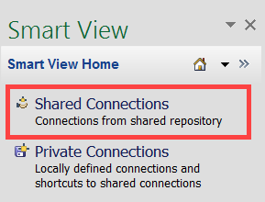
- Enter your User Name and Password and click Connect:
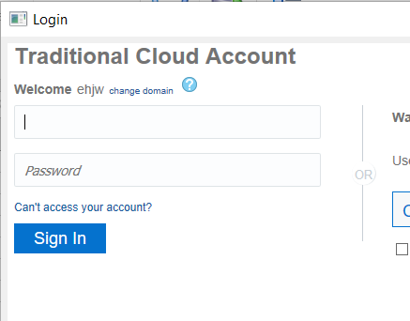
- Under Shared Connections, click on the dropdown that says "Select Server to proceed" and click Reporting Settings
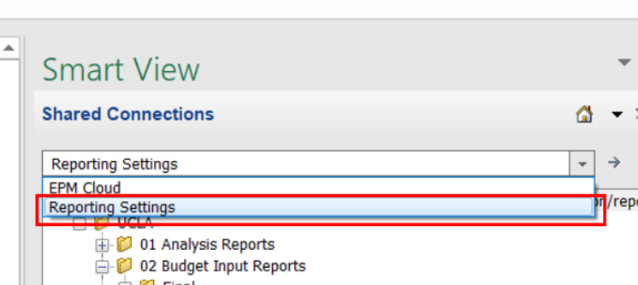

2b. Setting Smart View User Options
- From the Excel ribbon, click the Smart View tab.
- From the Smart View tab, click the Options icon:
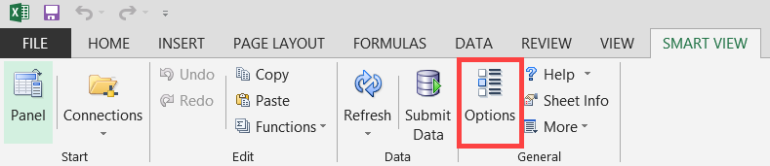
- Select Data Options and deselect all suppression options.
- Change the #NoData/Missing Label to a dash, blank, or 0 (zero):
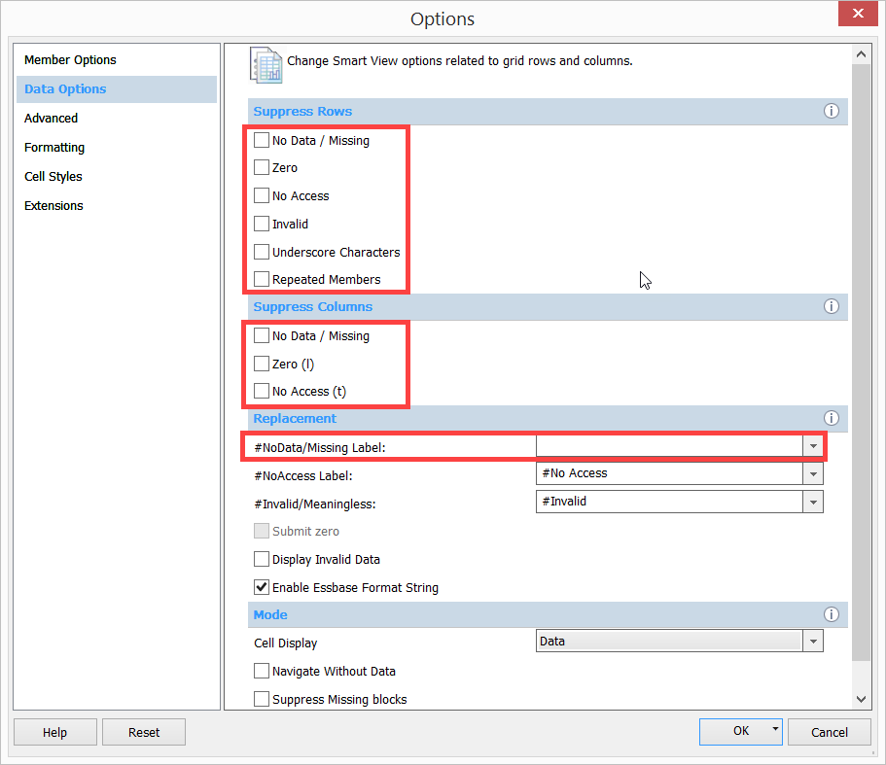
- In the Options, select Formatting and select the Adjust Column Width option.
- Once the Smart View Options have been set, click the drop down arrow next to the OK button.
- Click Save as Default Options:
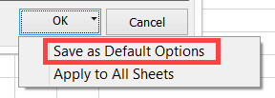

Opening Input Forms through the Task List
The Task List allows you to access reports and input forms. It opens the reports through the web application.
- Under Shared Connections, click on the dropdown that says "Select Server to proceed" and click EPM Cloud:
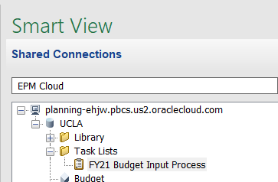
- Follow the path above and under Task Lists double click on FY21 Budget Input Process
- The task list shows the main steps needed to get through the budget input process. This includes reviewing some reports, and also opening up and completing the two budget input forms.
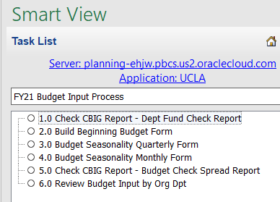
  - Task 1.0: Check CBIG Report – Dept Fund Check Report. This report provides an opportunity to view which funds have had actual activity over the past two years.
    - Double click on the first task. The C-BIG webpage will appear in your web browser (after you double click on the task) and you will need to log in to view the report on the web application.
    - After signing in to the C-BIG web application, select the Budget icon:
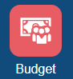
    - You will see 6 icons on the left hand side of your window. Click the first icon:
    - Select your department by clicking on the “Entity” box on the top left hand corner.
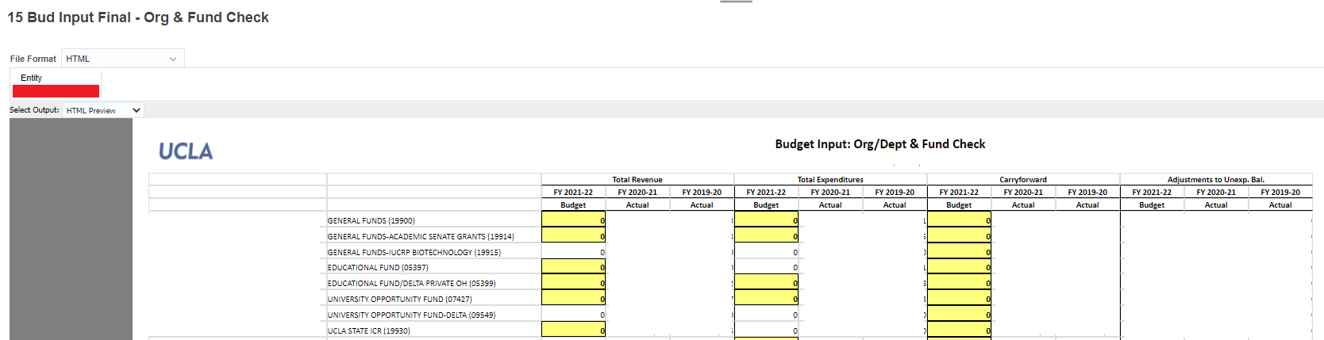
Note: Historical actual and budget numbers will show on this form – this form is blank for the purpose of not displaying any department’s numbers
  - Tasks 2.0 - 4.0: Double click the Beginning Budget Form and Budget Seasonality Forms. You only choose one of the seasonality forms quarterly or monthly (quarterly or monthly). The selected forms will appear in the current Excel sheet. These forms will allow you to input your budget and spread the budget across 4 quarters or 12 months.

Build Beginning Budget Form:
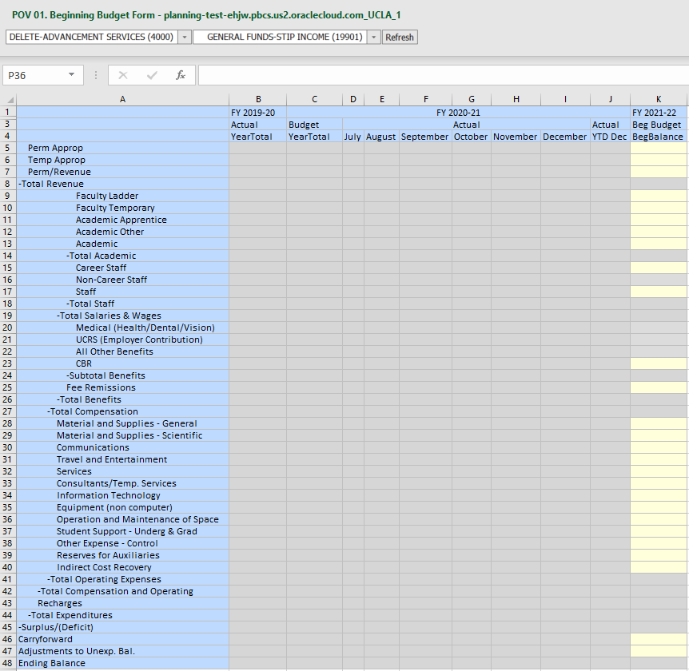
Note: Historical actual and budget numbers will show on this form – this form is blank for the purpose of not displaying any department’s numbers

Budget Seasonality Form (Quarterly or Monthly):
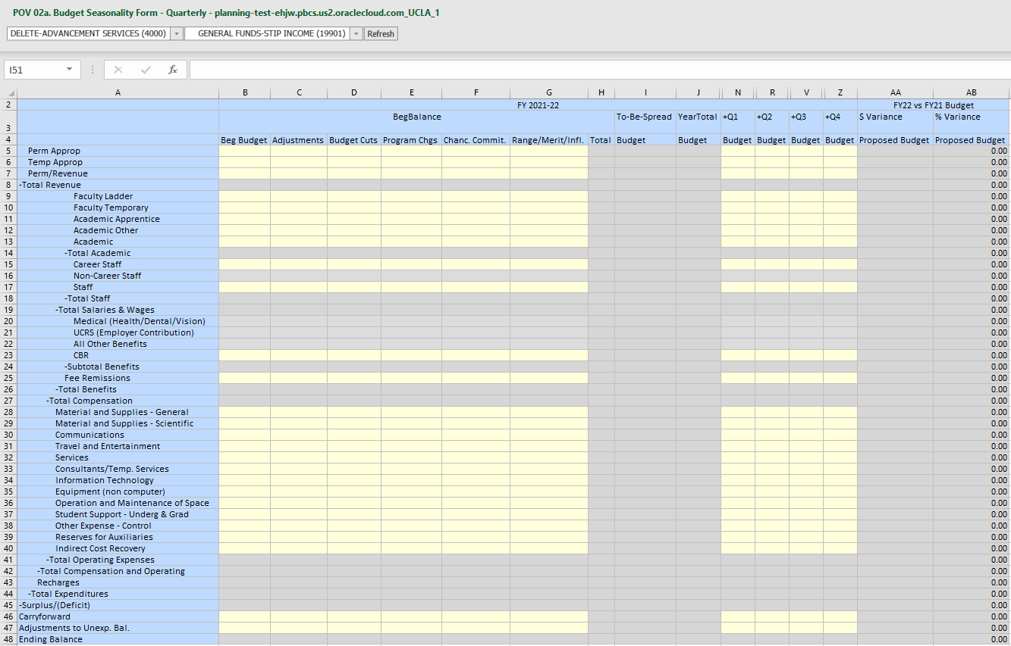
Note: Historical actual and budget numbers will show on this form – this form is blank for the purpose of not displaying any department’s numbers
Use a new sheet to open multiple reports/forms in one Excel workbook.
  - Task 5.0: Check CBIG Report – Budget Check Spread Report. This report allows you to confirm how much of your budget still needs to be spread. The goal is to ensure that your budget as entered in the Beg Budget form has been spread across quarterly/monthly in a Budget Seasonality form. You should see zeroes in the “to-be-spread” column once completed.
    - Double click on the task, and the C-BIG webpage will appear in your web browser and you will need to log in to view the report on the web application.
    - After signing in to the C-BIG web application, select the Budget icon:
    - You will see 6 icons on the left hand side of your window. Click the fifth icon:
    - Select your department by clicking on the “Entity” box on the top left hand corner.
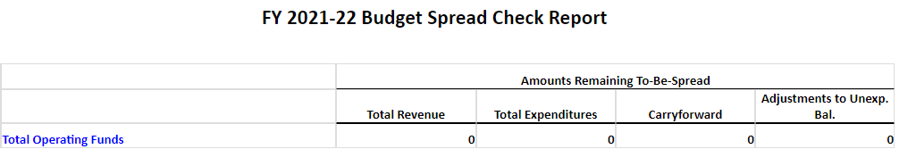

  - Task 6.0: Review Budget Input by Org Dpt. The selected form will appear in the current Excel sheet. This form will allow you to view a summary of your budget input by type of expense for all departments at once.
    - Select the fund and object on the top left corner and click refresh.
    - Double click on the cell with your Org name (column A) to open up the hierarchy and get to your departments.

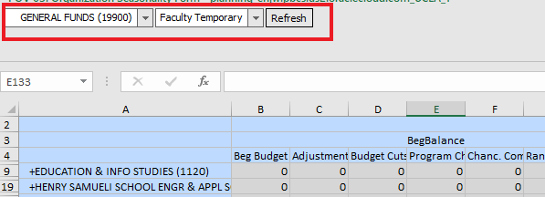

4. Using Budget Input Forms
The task list contains the two budget input forms seen in section 3. These include “2.0 Build Beginning Budget form” and “3.0 budget Seasonality Quarterly Form”. Instead of the quarterly form, you can choose to input into the monthly form “4.0 Budget Seasonality Monthly Form”.

4a. Selecting Department & Fund
There are two drop-down menus on the input forms you have opened in Excel. The left drop-down menu allows you to select your department, and the right drop-down menu allows you to select your fund. After changing your selection, you must click the Refresh button to reflect the changes.

To change your department,
- Select a department from the left drop-down menu and click Refresh:
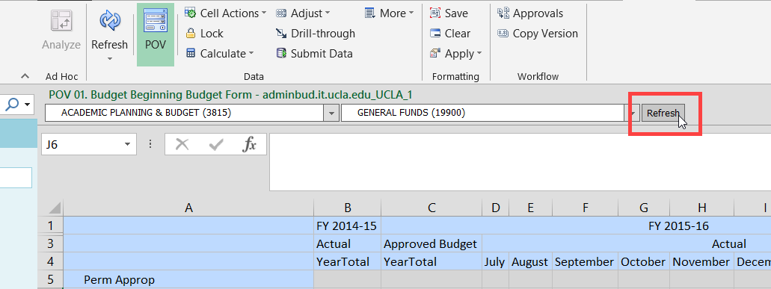
To change your fund,
- Select a fund from the right drop-down menu and click Refresh.

To use the search feature,
- Click in the department or fund drop-down menu.
- Type one or more characters (alphanumeric) of the department or fund name for which you are searching.
- If you know the fund number but not the fund name, you can check our fund mapping table which is also on the APB website.
- Select from the list that appears and then be sure to click Refresh.
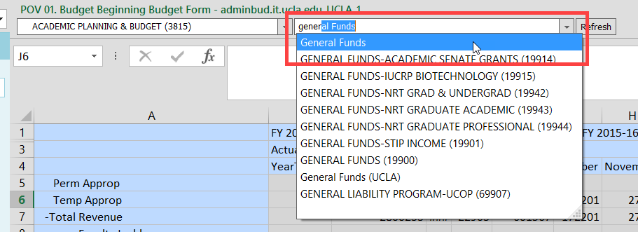

4b. Inputting and Submitting Budget Data
The cells with a grey background color represent read-only cells, while those with a light yellow background color represent input cells. After inputting data, the cell color will change to dark yellow, indicating that data has been changed but not yet submitted/saved to the database.
To submit/save your changes,
- Click on Submit Data from the Planning ribbon:
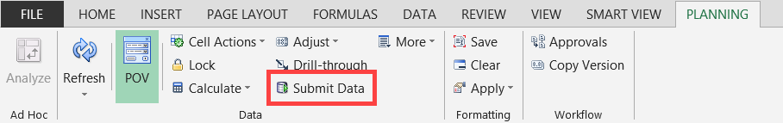
- If you get an error or the data will not submit (data disappears), please click Refresh and try again. If you are still having problems submitting data, please contact APB at apbcbig@ponet.ucla.edu, or contact someone from the APB Financial Analysis & Decision Support Team.

If, instead of saving your data, you would like to delete your unsaved changes:
- Click on Refresh from the Planning ribbon:
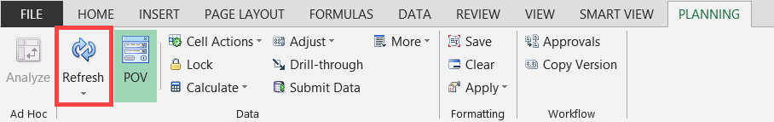
- At the following prompt, click on the OK button to confirm the Refresh command:
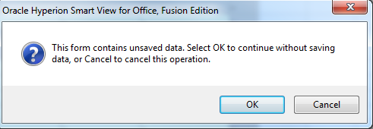

4c. Adding Cell Comments
To add Cell Comments,
- Select a single cell or a range of contiguous cells.
- Click on Cell Actions > Comments from the Planning ribbon:
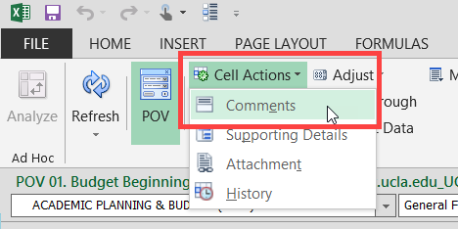
- Once the Comments window appears, click the + icon:
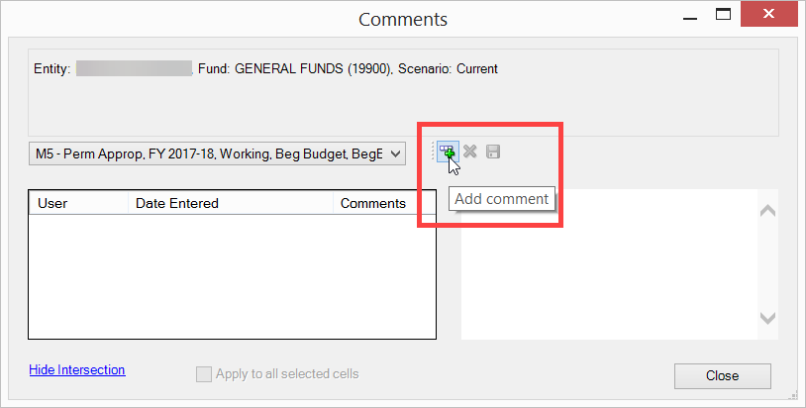
- Enter comments (up to 2000 characters per each cell), then click Save then Close.
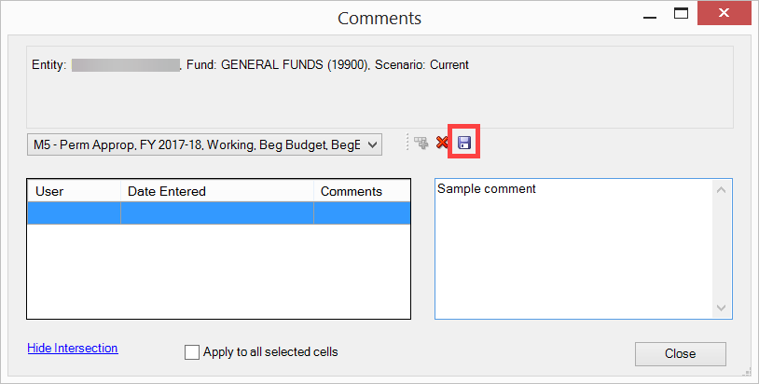
- The cell will have a blue border, indicating that cell comments are present.
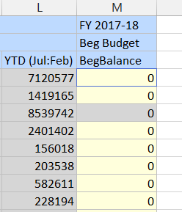

4d. Adding Supporting Details
Supporting details are used to provide more detail behind a number. To add Supporting Details,
- Select a single cell or a row of contiguous cells.
- Click on Cell Actions > Supporting Details from the Planning ribbon:
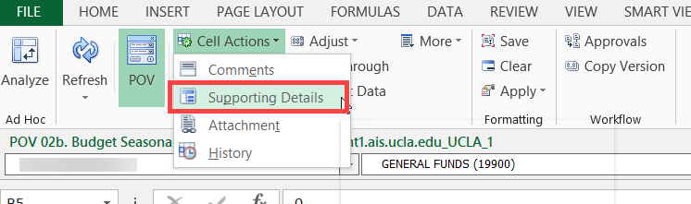
- Select the Add Child button.
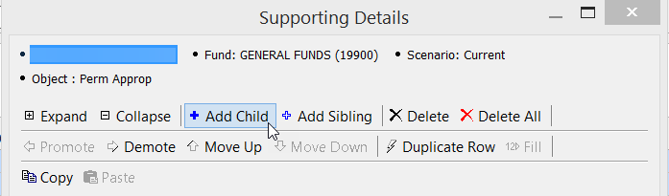
- Type a description over the default “Untitled”, select an operator, and enter an amount.

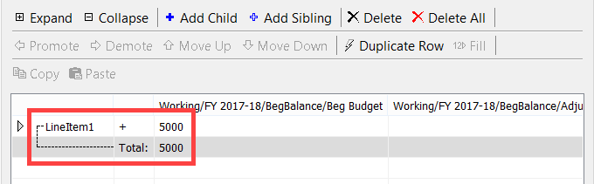
- To add line items, select the Add Sibling button.
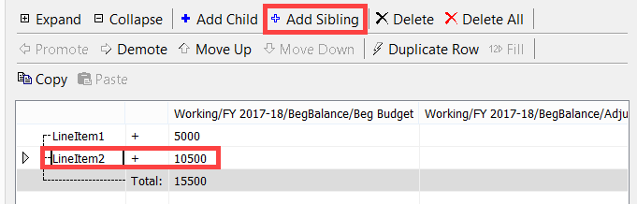
- Type in a description, an operator, an amount for the additional rows and click on the Submit button when done.

The total amount will display on your form, and the cell background color will appear in aqua blue, indicating that there are Supporting Details.
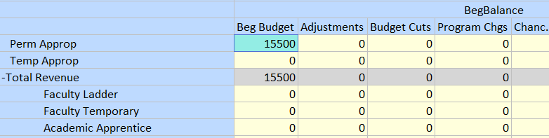
To delete Supporting Details, simply go to Cell Actions > Supporting Details > Delete or Delete All.

4e. Adjust
One cell or a range of cells can be adjusted by value or fixed percentage. To use the adjust function, highlight the cells you would like to change in a form, and in the Planning tab of Excel, go to Adjust > Adjust.
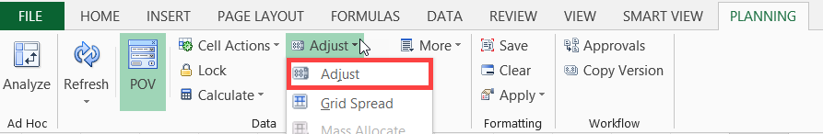
Select an adjustment option, enter the value or percentage, and then click Adjust Data.
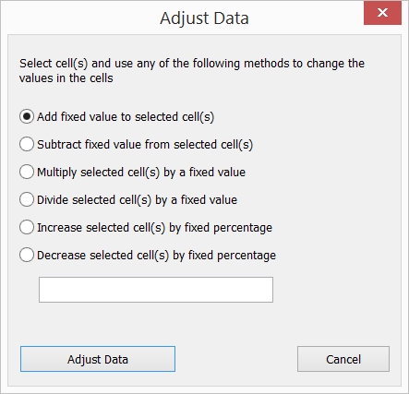

4f. Copying and Pasting
To copy and paste data from other Excel sheets, use Excel features (e.g. Ctrl c/x/v, dragging cell content, etc.).
If the cells that you are copying are protected, you may be prompted to first unprotect the sheet. Click the Review tab > Unprotect Sheet before copying.
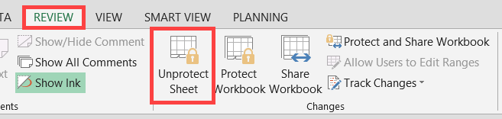

4g. Applying Excel Formulas
The ability to apply Excel formulas to manipulate and analyze data is available. When applying Excel formulas, keep the following in mind:
- You can create formulas inside or outside the data form’s grid
- You cannot create formulas on read-only cells or on cells that have Supporting Details
- Formulas are preserved upon saving or refreshing your data
- You must save workbook as an Excel file
- A separate sheet must exist for each department and fund combination containing formulas

4h. Running Calculations
Calculations, or business rules, are available for the forms in Smart View. There are three rules available from the Beginning Budget Form and Budget Seasonality Form.
To access the business rules,
- Right-click on a row within the form and select a calculation from the Smart View menu. This can also be accessed by selecting Calculate > Rules on Form from the Planning ribbon.

Beginning Budget Form:
The business rules for the Build Beginning Budget Form will populate Salaries and Operational Expense rows on the form. Users may right-click ANY of the rows (e.g. Faculty Ladder) and select a calculation to run for all the Salaries and Operational Expense rows:
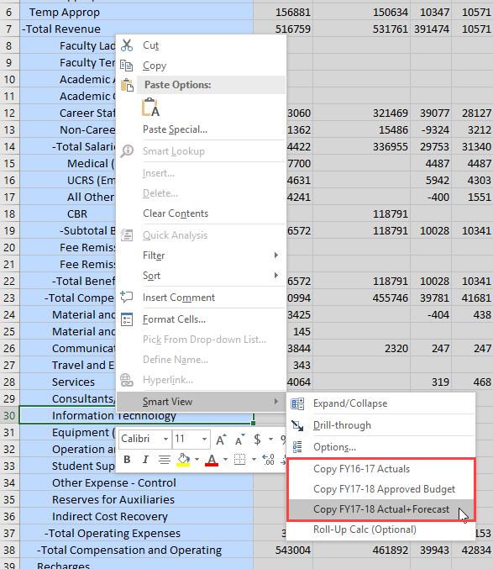
Budget Seasonality Form:
Business rules available for the Budget Seasonality Quarterly/Monthly Form are run for selected rows. Therefore, it is important that you right-click on the specific row you would like to alter.
To apply the calculation to multiple rows, right-click on the appropriate subtotal/parent row, then select the calculation (e.g. Selecting Total Salaries & Wages would apply the calculation to Faculty Ladder, Faculty Temporary, Academic Apprentice, Academic Other, Career Staff, and Non-Career Staff rows).
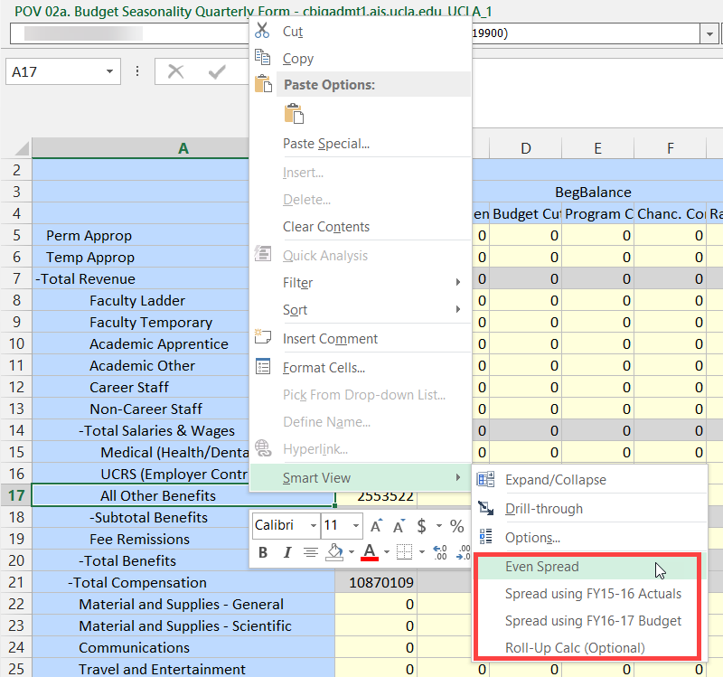
The rule will run and your beginning budget will be spread to the quarters/months (depending on what form you are using).

5. Data Validation
Data validation has been built in to the Beginning Budget Form and Budget Seasonality Quarterly/Monthly Form. There are two types of data validation: Deficit Budget Check and Spread Check.

5a. Deficit Budget Check
If you enter a budget that results in a deficit at the Ending Balance row, Total or YearTotal columns, the cell will be highlighted in yellow. You may also notice a Data Validation Message, stating, “Please resolve the deficit budget prior to submitting” when the cell is highlighted. You must correct the deficit budget; however, the system will not prevent you from submitting deficit budgets for approval.

5b. Spread Check
The Budget Seasonality Form will also check for To-Be-Spread amounts for each input row. If the To-Be-Spread amount is greater than 1 or less than -1 on a data input cell, the cell will be highlighted in yellow and a Data Validation message stating, “Please adjust your spread to match the annual budget” will appear. All To-Be-Spread issues must be resolved prior to submitting your budget.
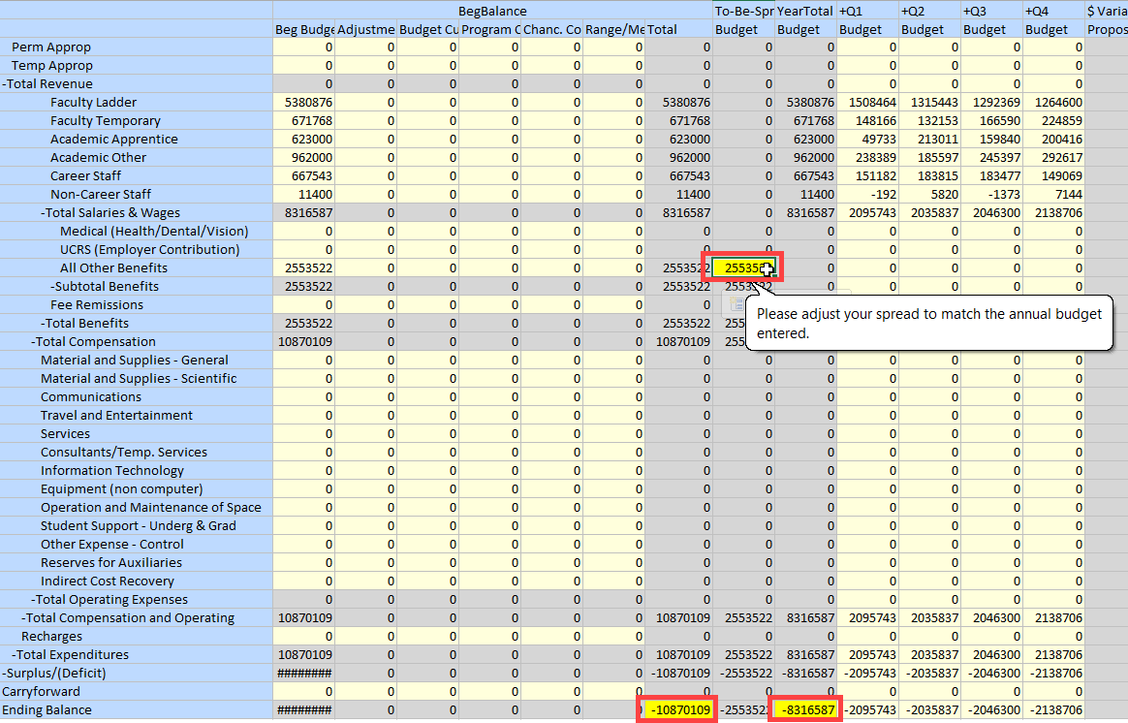

6. Approval Process
The Approval process will NOT take place in C-BIG for the 2021-22 Budget Year. C-BIG users will be locked out of the system by the budget submission deadline.

7. Logging Off Smart View
To log off,
- From the Smart View Panel, click on the down arrow next to the Home icon.
- Select Disconnect All.
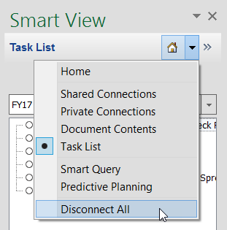
- Close Excel.

8. Troubleshooting
In the case that an error message appears while inputting budget, or your data cannot be submitted, please ensure that you have installed the latest version of Smart View. The latest version can always be found on the APB C-BIG webpage under the Download Smart View section.
In addition, many errors result from incorrectly installing Smart View. When installing, please remember to right-click the installation file and select “Run as Administrator”. Please uninstall a prior version (if found in the Remove Programs section of the Control Panel – sometimes it is not, depending on the version) before installing a new Smart View version.
Do not hesitate to contact APB at apbcbig@ponet.ucla.edu, or contact someone from the APB Financial Analysis & Decision Support Team.

